# CS 340 README

**About the Project/Project Title – Grazioso Salvare Dashboard**

The overarching goal of this project was to create an interactive dashboard to assist the activities of Grazioso Salvare, an organization that trains rescue animals. The organization wanted a quick and easy way to identify candidate shelter animals for the rescue animal training program. The dashboard allows users to quickly and easily filter the large collection of data provided by the Austin Animal Center, in order to find such candidates.

## Motivation

Grazioso Salvare is always looking for promising new candidates to train in their search-and-rescue dog training program. However, they have historically had to dig through large, unwieldy datasets to accomplish this. We here at Global Rain have partnered with Grazioso Salvare to make the identification and selection program much more user-friendly and streamlined through the use of an interactive dashboard. This interactive dashboard is fed data, through a CRUD module, from a MongoDB collection.

MongoDB was selected for this project because it interfaces well with Python and provides data in an easy-to-work-with format. Specifically MongoDB stores and manipulates items in BSON format, which is similar to the widely popular JSON format, but is binary-encoded. This allows BSON to be transmitted and processed more quickly by computers, without sacrificing the easy to read and work with nature of JSON.

The Dash framework was chosen because it is quick to deploy, responsive, and interfaces with Python. Creating and deploying a robust dashboard can be accomplished with Dash in just a few days, if one knows what one is doing. As someone who cut their teeth working with HTML and JavaScript, I found it very easy to learn and deploy.

## Getting Started

To use the CRUD and dashboard modules, you will first need a MongoDB server furnished with a dataset. The installation and configuration or a MongoDB server is beyond the scope of this README. For more information on this process, please refer to the [MongoDB](https://www.mongodb.com/) website.

For this project, we used a historical dataset from the Austin Animal Center, which was in CSV format. This was imported using the following commands, which you can easily modify for your own purposes and applications:

mongoimport --username=*admin_username --*password=*admin_password* --port=*mongodb port* --host=*mongodb_host* --db AAC --collection animals --authenticationDatabase admin --type csv --file ./aac_shelter_outcomes.csv --headerline

Once the data has been imported, it is wise to create a user with read-only access to the AAC database. This can be done from the mongosh console with the commands:  
use admin  
db.createuser({user:”aacuser”,pwd:”*user password*”,roles:[{role:”readWrite”,db:”AAC”}]})

From here, the user can simply adjust the USER, PASS, HOST, and PORT variables within the dashboard Jupyter Notebook file to reflect the correct settings for their database and user. Once these settings are properly configured, the dashboard will fetch and display data from this database in its table.

## Installation

This project has a few dependencies: Python, MongoDB, and the Jupyter Dash, Plotly, Pandas, and Matplotlib Python modules. The installation instructions for these dependencies will differ based on the user’s operating system. Please consult your vendor’s documentation and/or the dependencies websites for more information.

To learn how to deploy and work with the Dash I referred to its documentation, located here: <https://dash.plotly.com/dash-in-jupyter>

For guidance creating the necessary MongoDB queries for each filter, I referred to the MongoDB documentation, located here: <https://www.mongodb.com/docs/manual/reference/operator/query/>

## Usage

Usage of the interactive dashboard is quite simple and intuitive, but I will briefly go over the functionality here.

When the dashboard is first started, the user is presented with a table of the unfiltered dataset. The dataset is broken down, so as not to overwhelm the user, showing 20 entries per page. Pages can be changed using the forward and backward arrows at the bottom-right of the data table.

Data can be sorted by clicking the column titles, and can be filtered by typing criteria into the text boxes at the top of the columns. Selecting a row from the table displays the dog’s location on an interactive map at the bottom-right of the dashboard.

Grazioso Salvare seeks rescue animals who are good candidates for water rescue, mountain or wilderness rescue, or disaster and individual tracking rescue. To facilitate the easy location of candidates for these categories, we have created radio buttons that filter the list based on the ideal qualities for each category.

One of the main selection criteria for these categories is the dog’s breed. Since many dogs are mixed breeds and overly-stringent search terms can result in relatively few (or even no) results, we have also included radio buttons to allow for the search to be expanded to included dogs of mixed heritage. These selection filters can be found in the upper-left corner of the data table.

Upon the application of a dataset filter, the result count, pie chart breakdown, and map all update to reflect the new search results.

### Code Example

The CRUD module the underpins the dashboard contains several functions. Namely, init, create, and read, update and remove. These are described below.

__init__(self) : Connects to the MongoDB database.  
Example: accdb = AnimalShelter()

create(self,data) : Creates and inserts a new document within the AAC databse. Takes a document (data) as input. Returns True or False depending on whether or not a document is successfully inserted.

Example: aacdb.create({“animal_type”:”cat”,”breed”:”Bombay”,”name”:”Felix”})

read(self,query=None) : Finds and returns a matching document or documents from the AAC database. Takes an optional search query (query) as input. If no query is provided, it returns an empty list.  
Example: print(aacdb.read({“breed”:”German Shepherd”}))

update(self,query=None,replacement=None): Finds and modifies an existing document within the AAC database. Takes two arguments: query and replacement. The query argument provides the function with search criteria for the item to be updated, and the replacement argument tells the function which data in the query results is to be updated. Returns number of updates performed.

Example: print(aacdb.update({"name":"Alf"},{"$set":{"breed":"alien"}}))

remove(self,query=None): Finds and deletes a document from within the AAC database. Takes one argument: query. The query argument provides search criteria for the document that is to be removed. Returns the number of deletes performed.

Example: print(aacdb.remove({"name":"Alf"}))

### Tests

All CRUD module functions were tested with both valid and invalid input. Some examples are provided here to inform the creation of your own tests.

* **Valid create:**

newEntry = { "age_upon_outcome" : "28 years",

"animal_id" : "A92654", "animal_type" : "Dog?",

"breed" : "Mutt?", "color" : "Red/Brown",

"date_of_birth" : "1986-09-22",

"datetime" : "2014-09-18 18:35:00",

"monthyear" : "2014-09-18T18:35:00",

"name" : "Alf",

"outcome_subtype" : "???",

"outcome_type" : "Mysteriously Vanished",

"sex_upon_outcome" : "Male",

"location_lat" : "34.25",

"location_long" : "118.45",

"age_upon_outcome_in_weeks" : "1460.00"

}

print(aacdb.create(newEntry))

* **Invalid create:**

print(aacdb.create({0:0}))

* **Valid read:**

print(aacdb.read({"name":"Rex"}))

* **Invalid read:**

print(aacdb.read({0:0}))

* **Update with valid inputs:**

print(aacdb.update({"name":"Alf"},{"$set":{"breed":"alien"}}))

* **Update with invalid inputs:**

print(aacdb.update({0:0},{0:0}))

* **'Delete' (Remove) with valid input:**

print(aacdb.remove({"name":"Alf"}))

* **'Delete' (Remove) with invalid input:**

print(aacdb.remove({0:0}))

### Screenshots

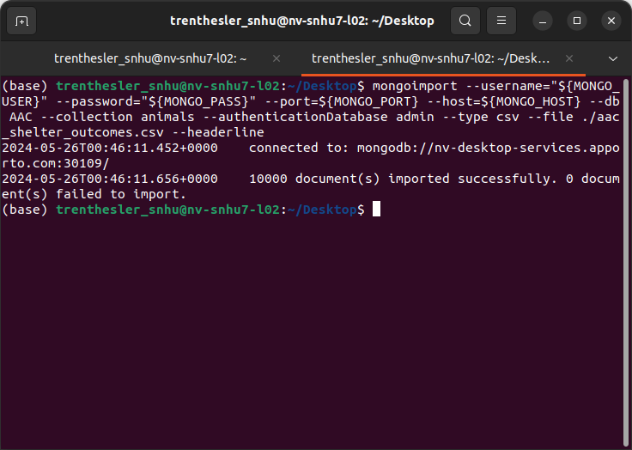

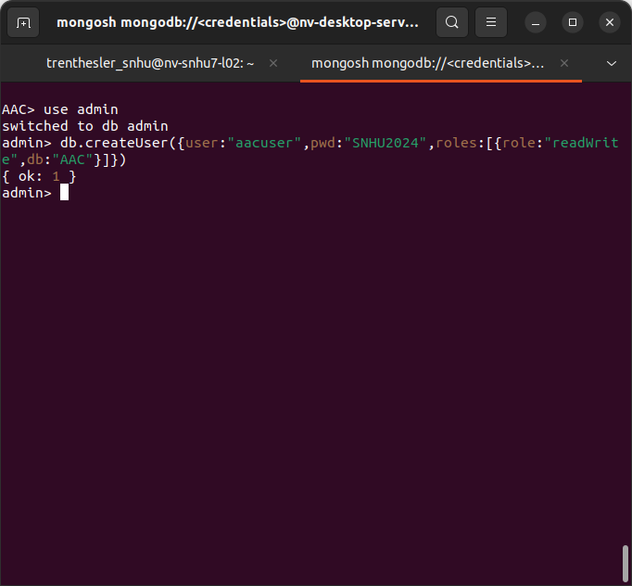

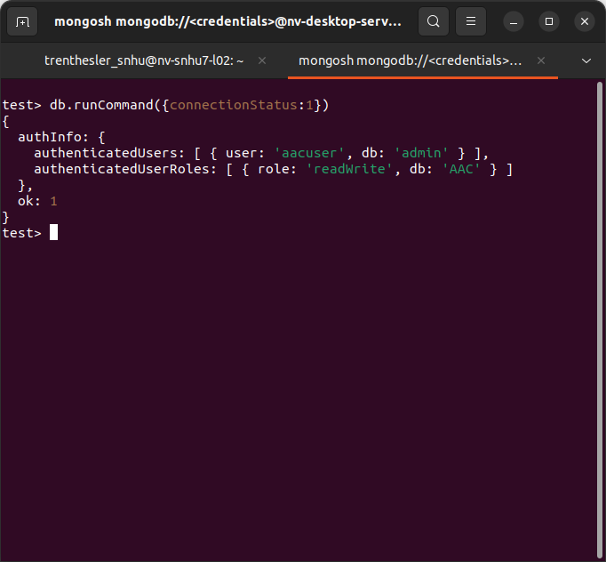

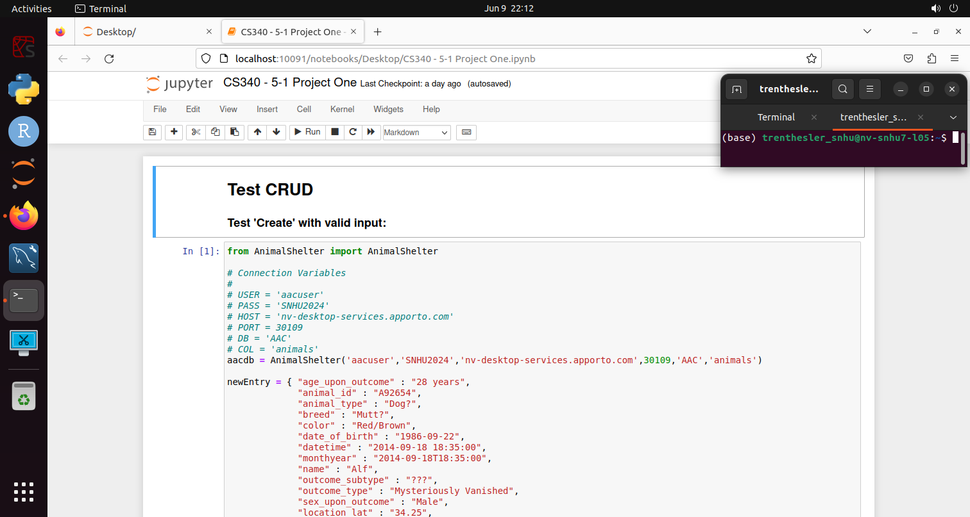

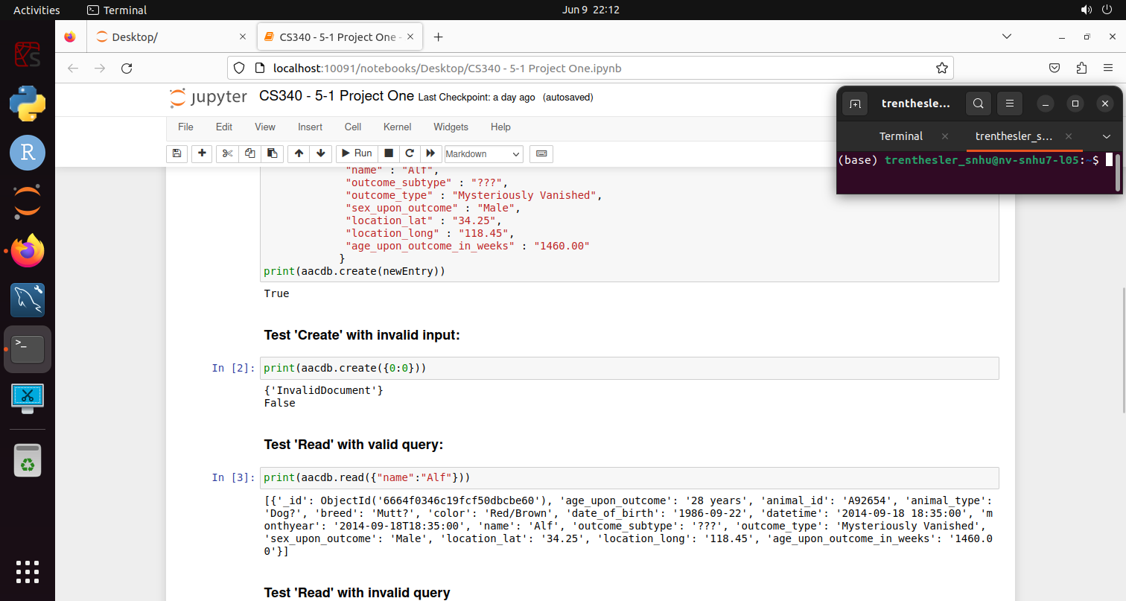

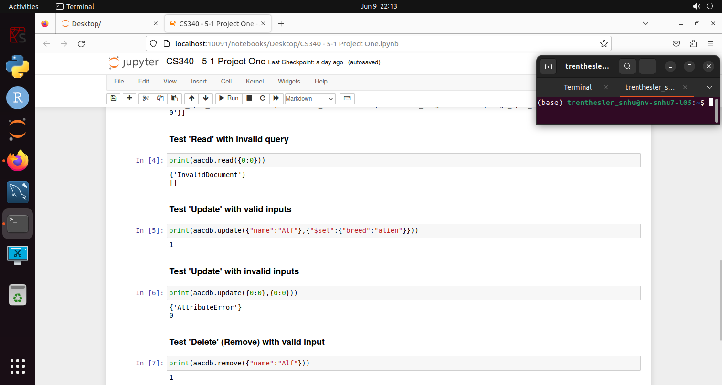

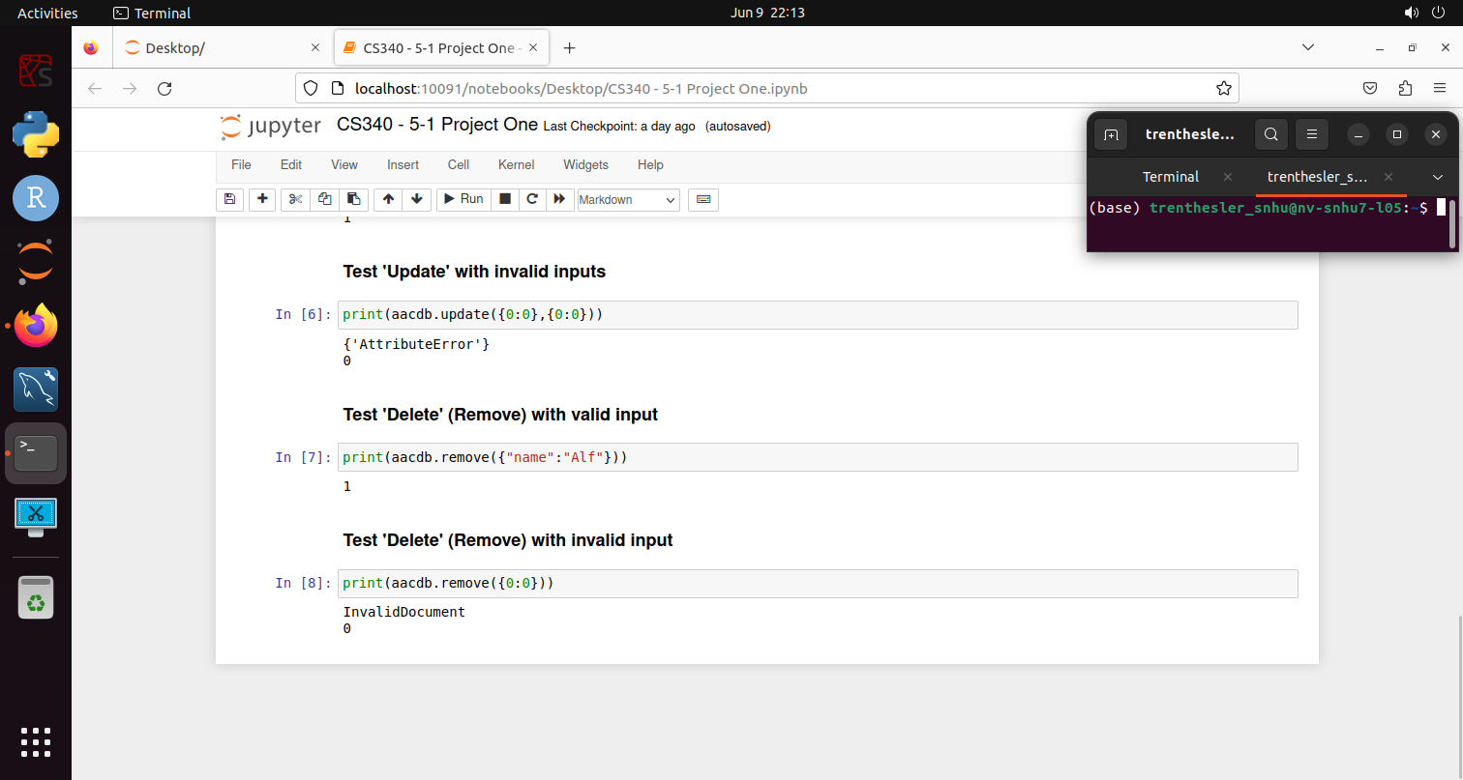

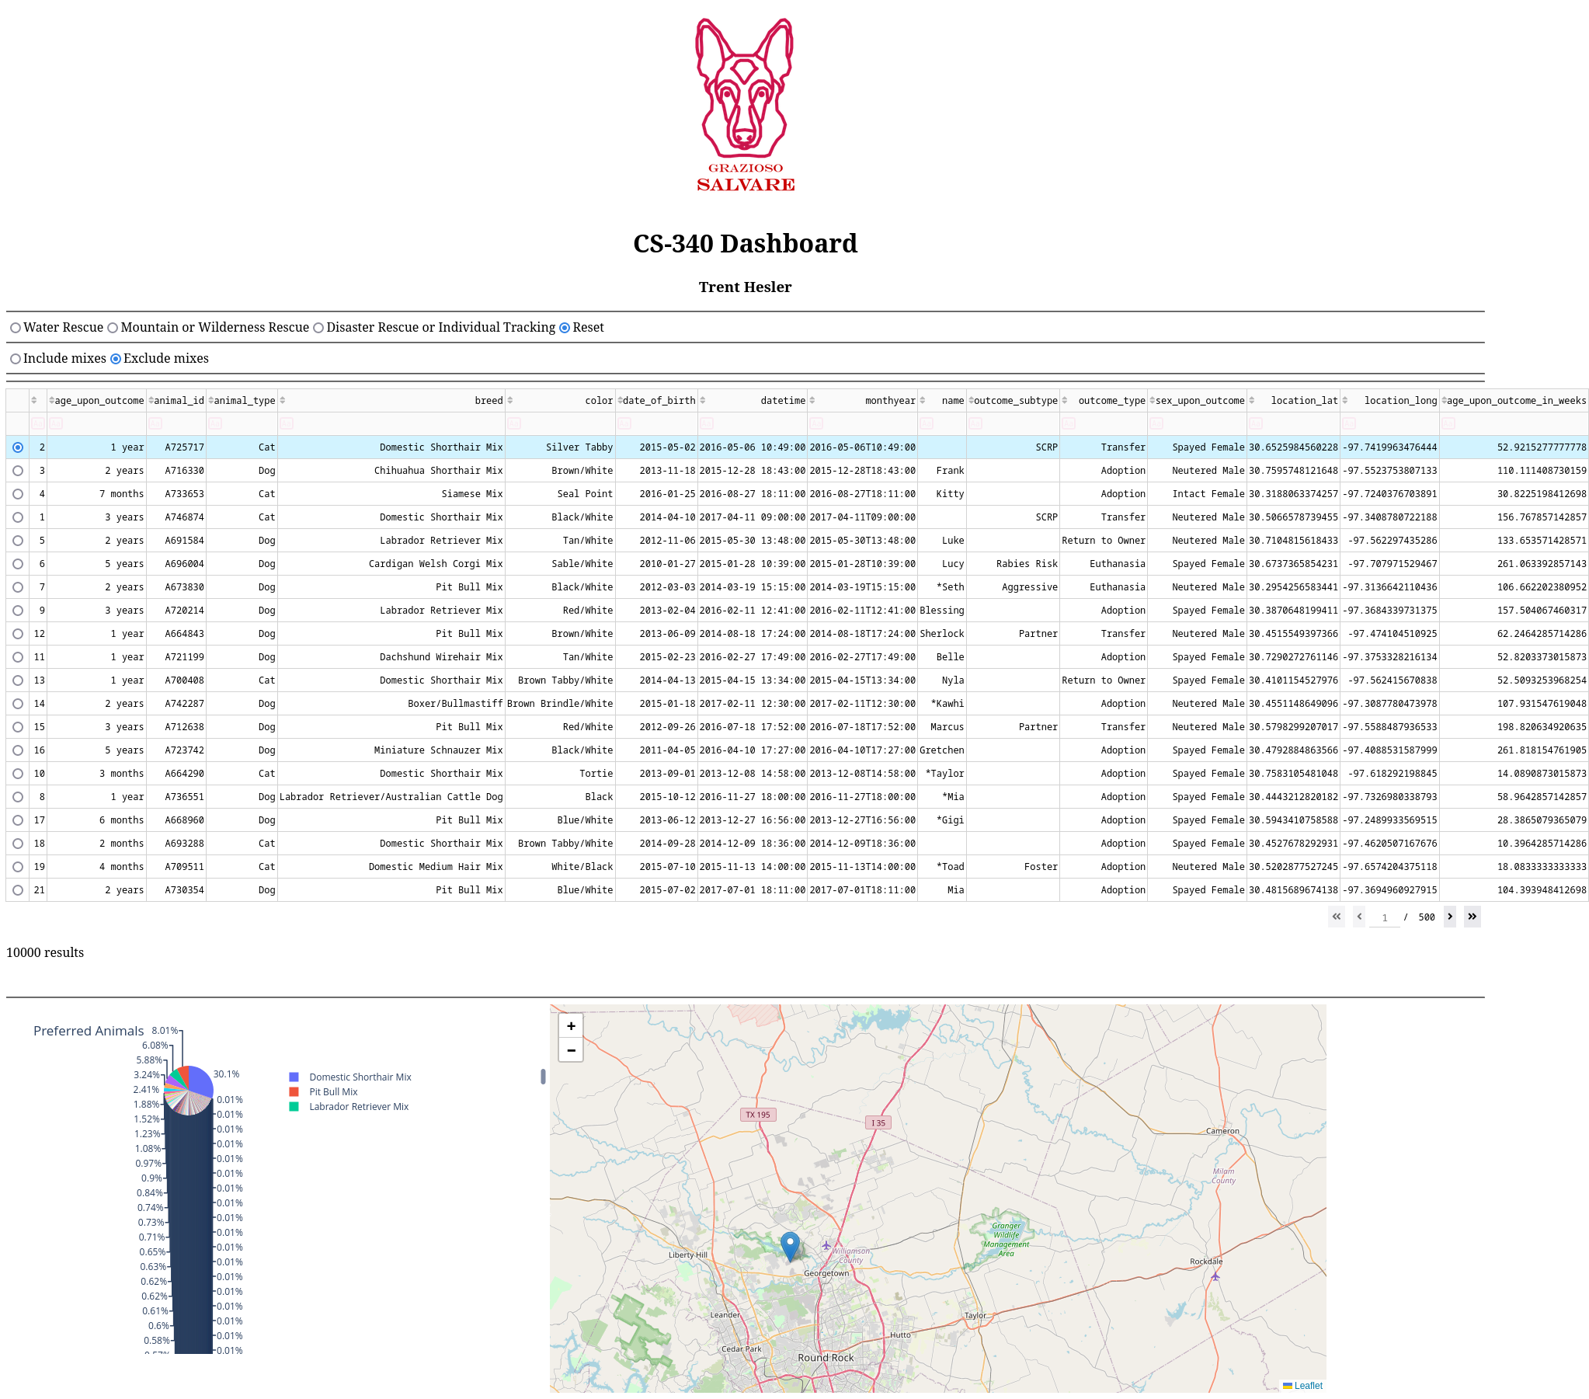

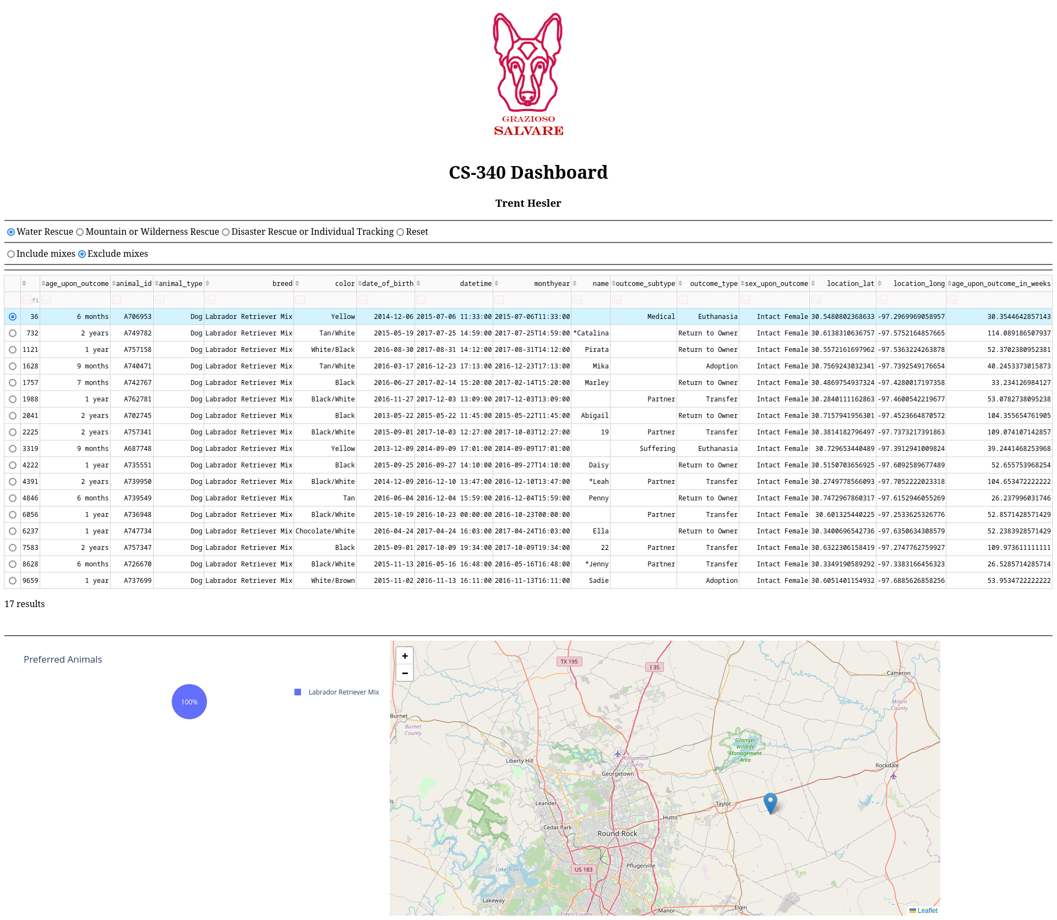

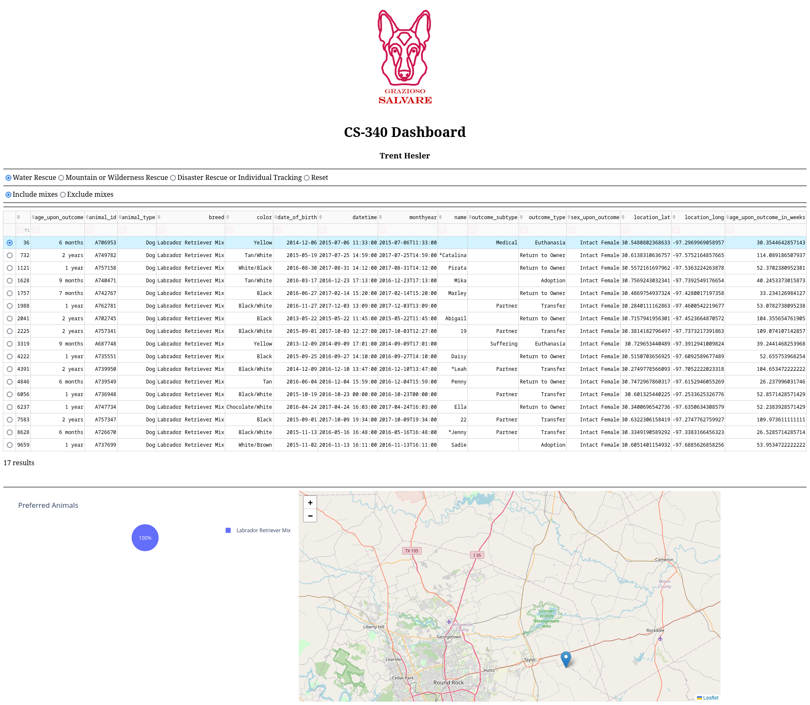

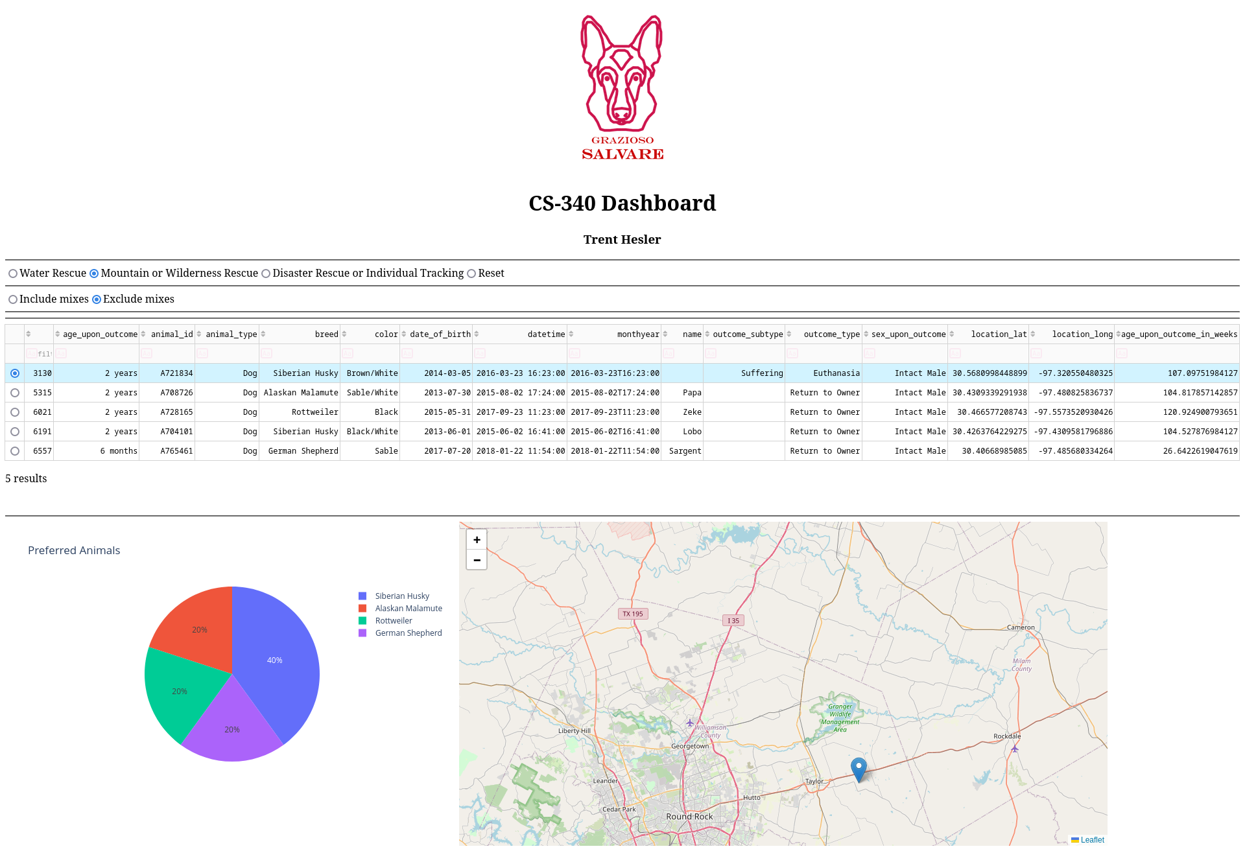

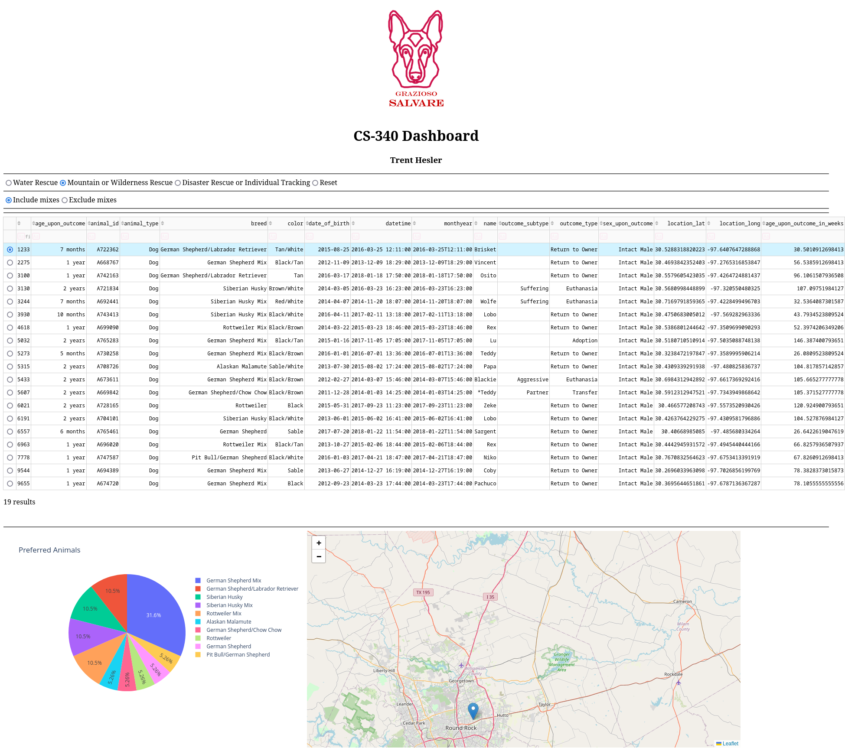

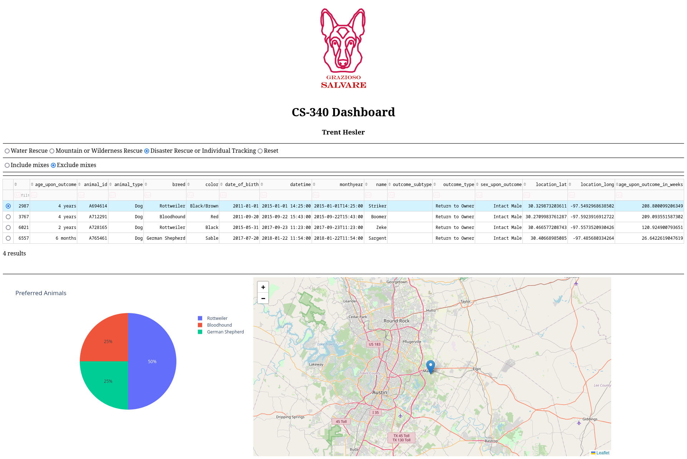

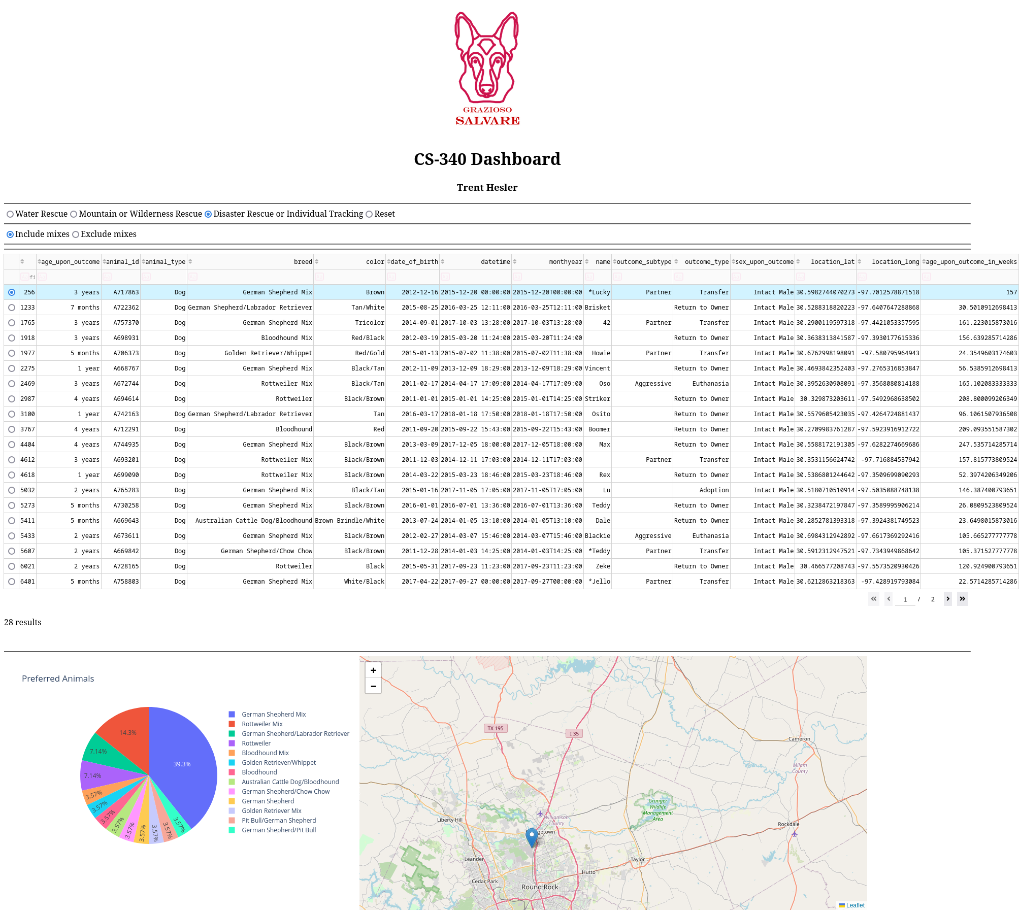

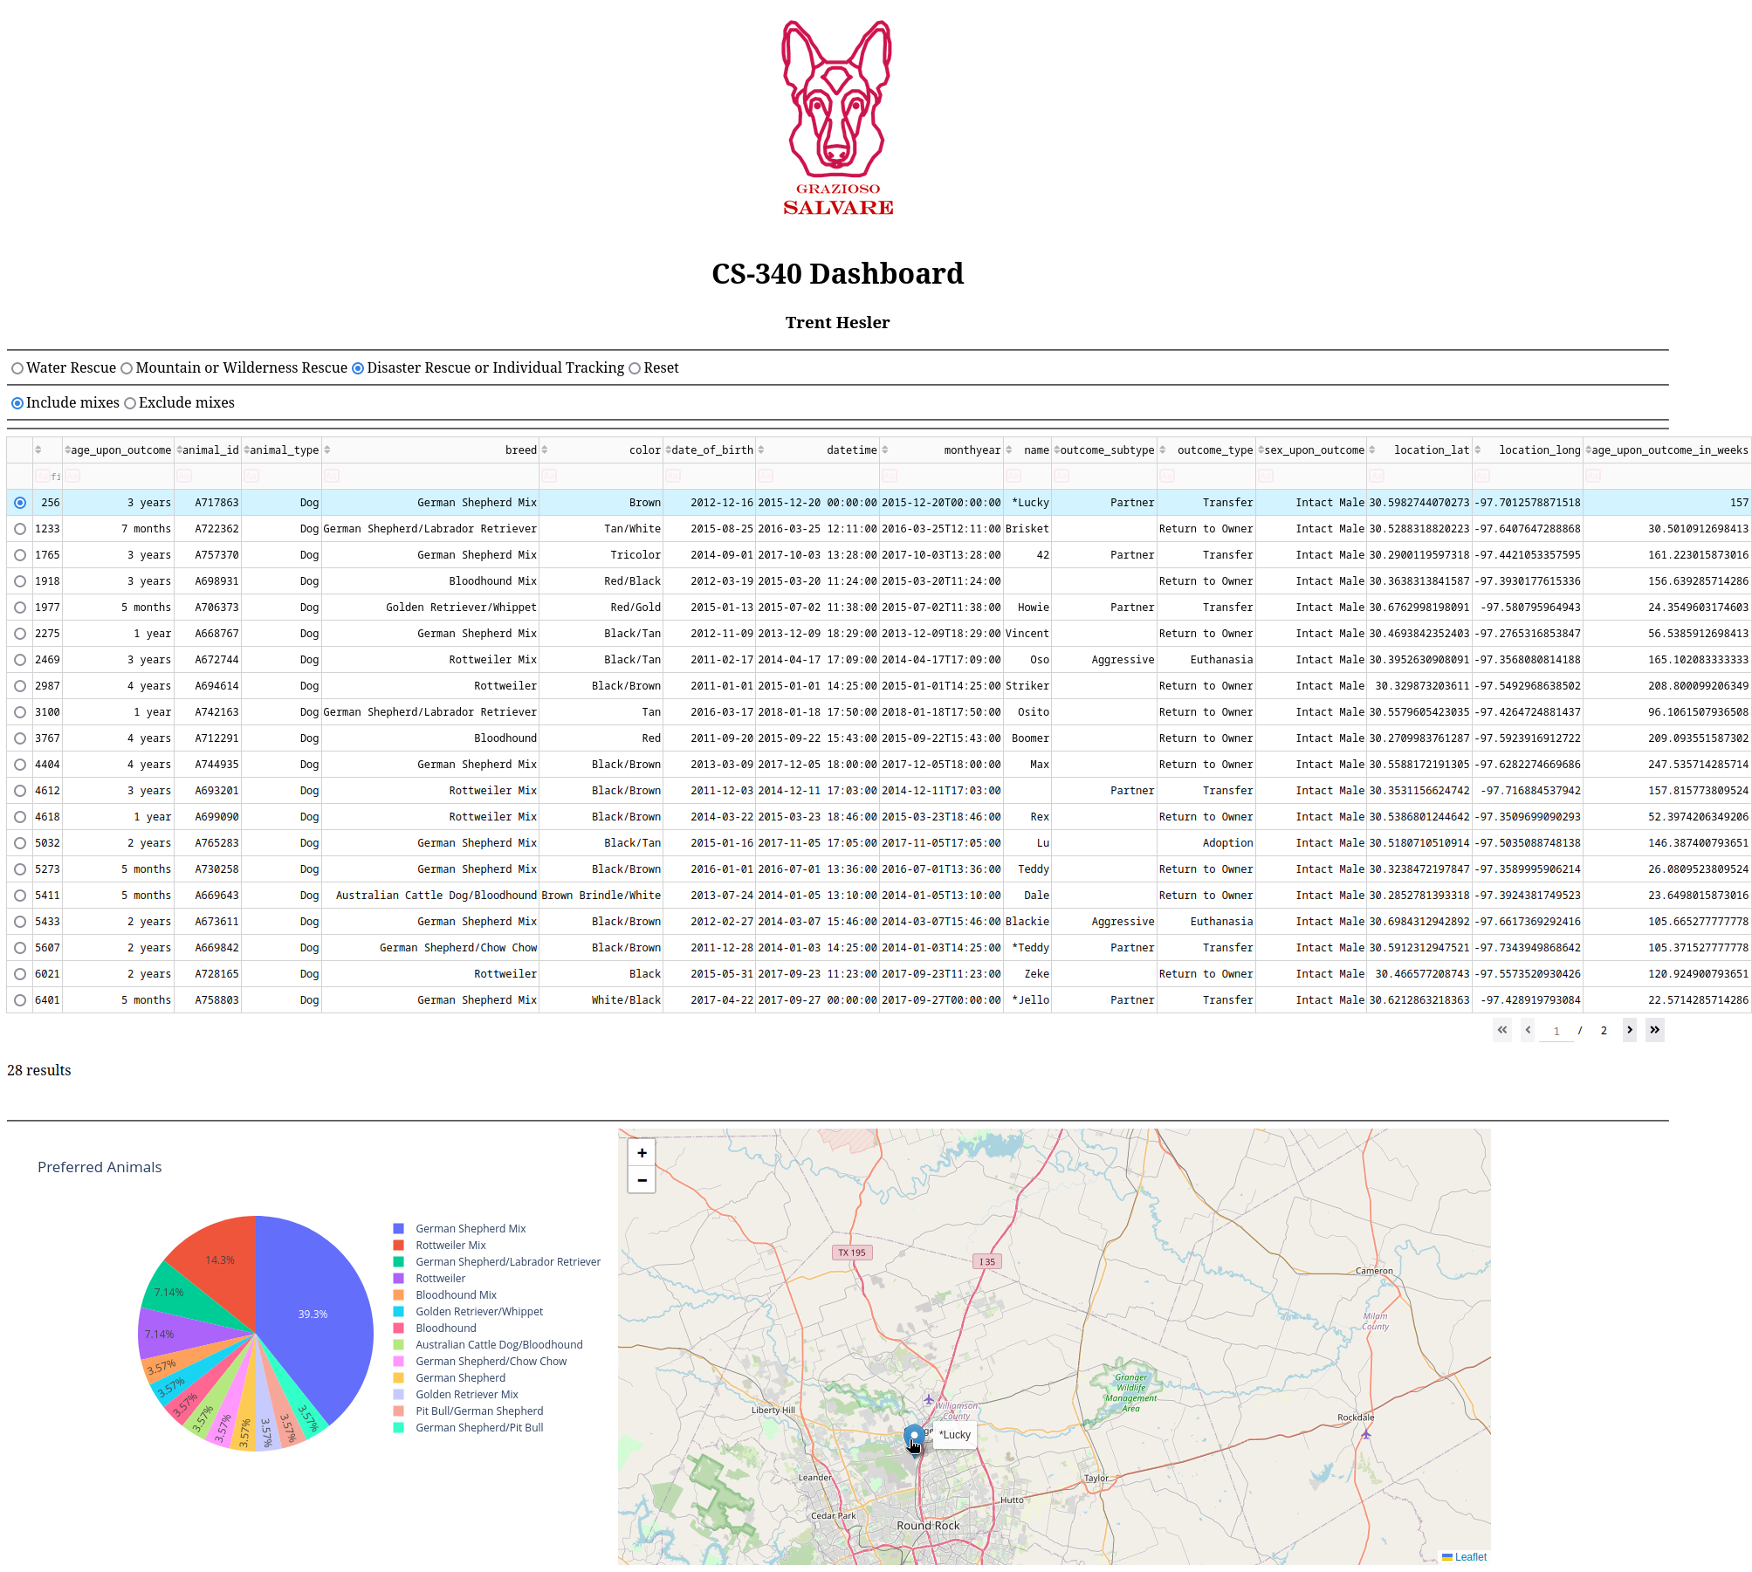

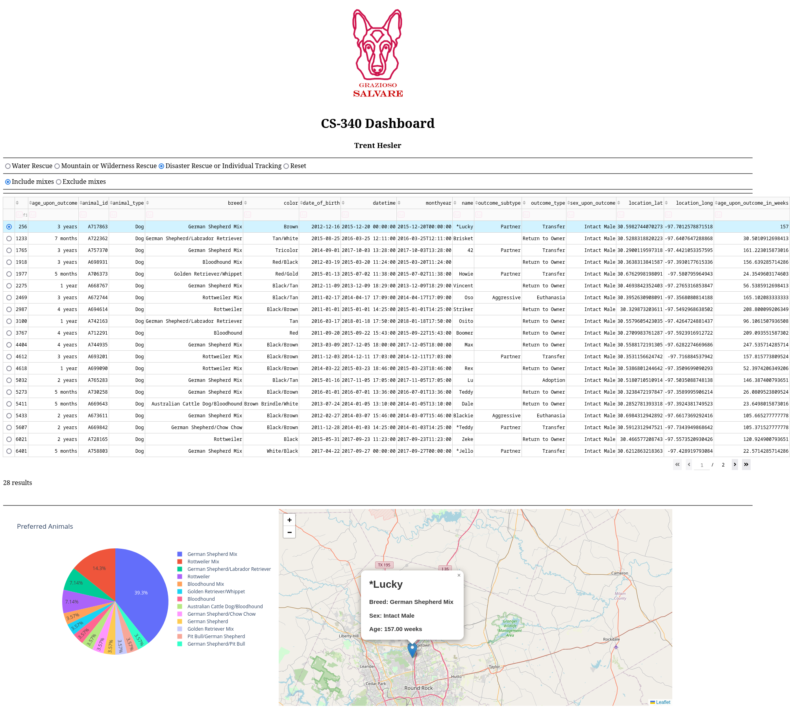

## Contact

Your name: Trent Hesler ([trent.hesler@snhu.edu](mailto:trent.hesler@snhu.edu))